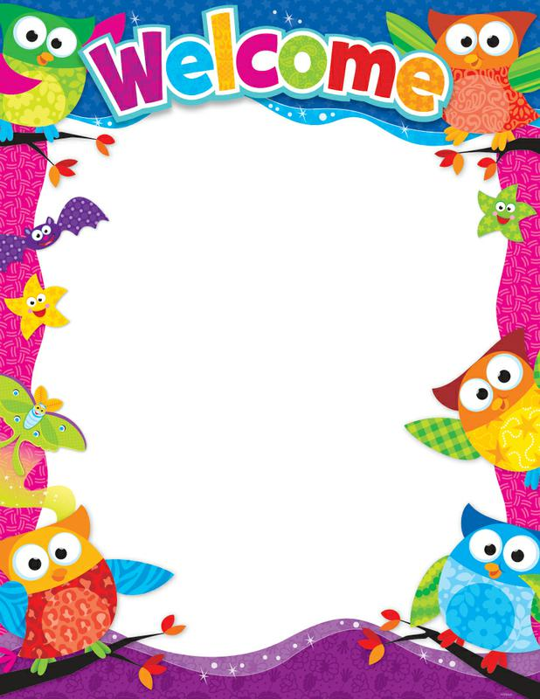

Dear Parents/Guardians,

Congratulations on completing the registration process and welcome to the Ojibwa Elementary Kindergarten program. This is an exciting time for you and your Kindergartener. This year will be one of the most important milestones in your child’s life - the first year of school. By working together, we can make it a fun and rewarding experience.

We understand the importance of preparing our families for the upcoming school year, so you are invited to a special Kindergarten Kick-Off on Tuesday, May 23rd at 6:00 p.m. We will be giving out information on how to best prepare your child for the upcoming school year. This event is for incoming Kindergarteners and their parents only, no siblings may attend please.

During the month of August, we will host a Kindergarten Curriculum Night and you and your child will be invited to attend together again. This event will give your child an opportunity to meet their teacher and tour the school. Details regarding this event will be mailed to you in the summer.

We are committed to doing our best to make this school year a fun filled learning experience. The skills we practice in Kindergarten are the building blocks for your child’s future success.

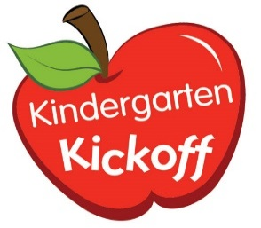
We look forward to meeting with parents at Kindergarten Kick-off on Tuesday, May 23rd at 6:00 p.m.

Yours in Education,
The Ojibwa Kindergarten Teachers

