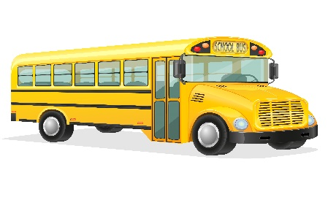
Chippewa Valley Schools
Transportation Department
19120 Cass Avenue
Clinton Township, MI 48038
(586) 723-2160 Fax (586) 723-2161
Email: transportation1@cvs.k12.mi.us
KINDERGARTEN TRANSPORTATION INFORMATION AND RELEASE FORM
(Please complete this form and return to your child’s school as soon as possible)

Students Full Name: _________________________________________________________________________
Student’s school:____________________________________________________________________________
Birth Date:_______________________ Gender:_____________ Nickname:________________
Parent/Guardian Name:_______________________________________________________________________
Street Address:______________________________________________________________________________
City:___________________________________________ Zip Code:___________________________________
Phone:_________________________________________ Fax:__________________________________
Cell:___________________________________________ Email:______________________________________
Contact(s): People who are authorized to pick up your child from the bus stop. (These people NEED to be on your student’s contact list on POWERSCHOOL and at your child’s school).
Student can be left unattended at bus stop: YES __________ NO__________
Name:_______________________________________________ Phone:____________________________
Name:_______________________________________________ Phone:____________________________
Name:_______________________________________________ Phone:____________________________
Medical/Allergies/Medicines:_____________________________________________________________________
______________________________________________________________________________________________
Please note that if the contact(s) change throughout the year, it is necessary to fill out a new form.
Other Information/Comments:______________________________________________________________________________
__________________________________________________________________________________________________
Parent Signature:___________________________________________________________________________________

